PLAYING AUDIO-ONLY GAMES
A COMPENDIUM OF INTERACTING WITH VIRTUAL, AUDITORY WORLDS

Niklas Röber and Maic Masuch
Games Research Group
Department of Simulation and Graphics
University of Magdeburg, Germany
nroeber|masuch@isg.cs.uni-magdeburg.de

ABSTRACT
Talking about games refers in today’s world often to the play of audio-visual computer games. Since their first introduction in the 1960s, computer games have evolved in many ways and are today one of the fastest growing industries. Besides the classic visual games, another niche has emerged over the last decade: audio-only computer games. The main difference to conventional games is that these games can only be played and perceived through sound and acoustics. Although, initially developed by and for the visually impaired community, these games posses huge potentials for mobile (transportable) gaming and can be enjoyed by all hearing.
In this work we present an overview of audio-only games, and discuss the methods and techniques to play and design such auditory worlds. We further explore the evolved genres and address the advantages, as well as the limitations of audio based gaming. Our work is motivated by our own research in this area and the development of a framework, which allows an easy design and setup of audio-only computer games.

Keywords
Audio-only computer games, 3D sound, auditory environments, sonification, interaction.

1. INTRODUCTION
Over the last decades, the notions of play and games have changed, and are today often referred to as the play of audiovisual computer games. But not only the concept of playing has changed, rather a new media was developed, which in today’s world influences our daily life in many aspects. In the beginnings, games were written by single persons, whereas nowadays they are the product of many people working collaboratively together for several month or even years. Over the last decades, games have not only evolved in realism and graphics, but also in genre, sound and opponent intelligence. One group that was nearly excluded from this are the visually impaired. But with the propagation of computing technology and advances in sound and acoustics, another class of games has emerged: Audio-only computer games. Audio based games are by definition similar to conventional video games, except that these games are played and perceived through sound and acoustics only [3].
Although, audio games are limited regarding the amount of information that can be conveyed, they posses many advantages that makes them very interesting for experimenting with gameplay ideas [7], [19]. One of these advantages is the increased degree of spatial freedom, as no screens are necessary, and hence gameplays are possible that allow a 360° field of interaction around the player. The computational complexity is usually lower than for visual games, and as less hardware is needed, these games are perfectly suited for mobile (portable) gaming. Even though, we are not explicitly focusing on games for mobiles and cell phones, but with the current advances in telecommunication and by using headphones, many of the here discussed techniques can be adopted as cell phone games. Another positive side effect of the missing graphical scene representation is the increased level of immersion. Similar to reading, or listening to audiobooks, this is due to the stimulated listeners phantasy, which envisions the scene in front of the minds eye.
The majority of audio games are still developed by small companies with the main audience being the visually impaired users [1]. Various game genre have evolved or were adopted from the visual domain. Through the advantages of speech and sound, audio games are especially qualified for the presentation of narrative content, as found in adventure and action adventure games [5], [10]. But also action [11] and strategy games [20] with varying complexity and difficulty are available. In the last years, several research groups have focused on the development of augmented audio technology that combines a real scenery with an artificial, acoustic environment [12], [21].
One disadvantage of audio games is that the correct rendering of 3D sound is technologically more complex than the generation of 3D images. This is due to the perception of sound and the utilization of listener unique features (shape of the outer ear). A good introduction into 3D sound and acoustic rendering can be found in the books by Begault [2] and Garas [9]. Regarding the programming of 3D sound, many libraries exist that can be used to render spatialized sounds, as well as which are able to emulate room acoustics. A slight drawback to these libraries is that the majority uses simplified algorithms and not a physically correct sound rendering.
Our framework is developed platform independent and uses in the current implementation OpenAL and EAX for the sound rendering. Due to limitations of OpenAL under Linux, we are at the present bound to Windows. At the moment we are also working on a more sophisticated sound system, which will provide a correct rendering of 3D sound and room acoustics under both, Linux and Windows, as well as feature individualized HRTFs. The framework uses OpenSG as scenegraph and 3D Studio MAX to design the 3D environment.
The paper is organized as follows: The next section discusses virtual, auditory worlds as the pendent to the 3D environment of visual games. We explain the differences in perception, as well as the necessary techniques to convey information and to interact with these auditory environments. The following section focuses on the design of audio games and motivates for the right balance between the games functionality and artistic demands. In this section we also discuss existing audio games and compare them with our own. Finally, the paper concludes with a summary and a brief lookout in future improvements.

2. AUDITORY WORLDS
Audio based computer games use auditory environments as stage for the game’s scene and play. The most prominent difference to classic games is the absence of any visual information, which has been replaced by sound that is now used to describe the scene and the story. Regarding the perception, several differences exist in sensing visual and auditory environments. Albeit the majority of information is perceived visually, some can only be experienced through hearing. In many situations, the ears are steering the eyes and move the attention to acoustically interesting locations.
Although we perceive sound as a whole, it can be divided into two groups. The first is called 3D sound and perceived through several listening cues. These cues allow a listener to determine the position and the distance of a sound sources with a precision of up to three degrees [2]. Information about the local environment is derived from room acoustics through reverb and echoing effects. Here, we are able to identify not only the room’s size, but also the material it is constructed off, and the objects that are located within the room.
As the amount of information conveyable through sound is limited, the auditory environment has to be enriched by additional sounds, which provide extra information about the scene and objects. Additionally, interaction is one of the main cues to interfere with the acoustic space and to gather information through realtime feedback. The next two sections focus on sonification and interaction techniques, which are used to communicate information and to control the game.

2.1. Sonification
The definition describes sonification as the mapping of abstract data to non-speech sound [3]. Examples can be found in the area of data sonification, like the Geiger-Müller radiation counter or in the analysis of seismic studies [18]. In auditory worlds, sonification is used to describe and explore the environment, as well as to identify scene actions and objects [14]. Several earcons are often additionally integrated into the environment to aid in the processes of navigation, orientation and interaction. Examples are beacons for an artificial horizon and compass, or landmarks that can be used to identify large objects (clock tower) or assist in the orientation in small environments (coffee machine, radio). Furthermore, scene objects can be equipped with auditory textures that portray them using alternative sounds depending on their current status [13].
Another navigational challenge are path sonifications, in which soundpipes and guides can be employed for assistance. Guides are not only useful for path sonification, but also as a narrator who controls the game and drives the story. Additionally, monologues of the main character can be included in the game to summarize complex scenes and to provide hints in difficult situations.

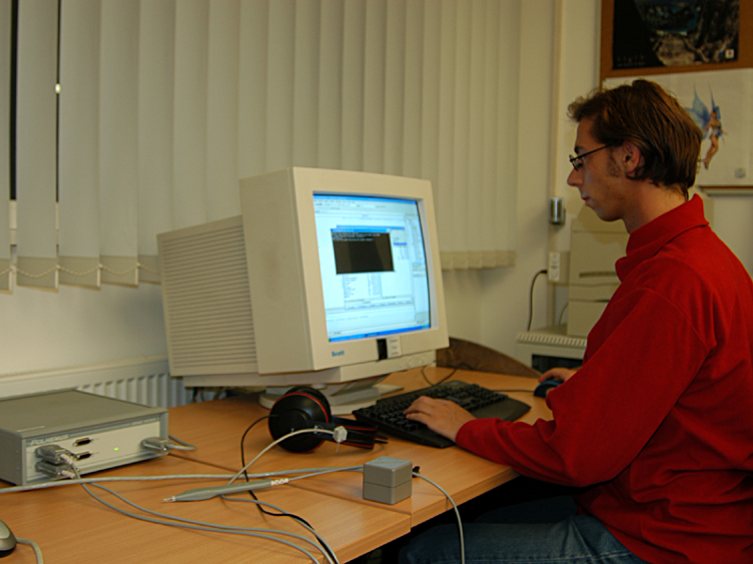

Figure 1: Tracking Equipment (Polhemus Fastrak)

In our framework we implemented most of the here described techniques. But not all of them have to be included into a game, and the difficult part still is to choose the right ones. As the goal is to immerse the player in a virtual, auditory world, we need to find the right balance between functionality and design.

2.2. Interaction
As important as a sound scene sonification are the right tools for the interaction with the environment. These techniques are used to probe the environment and to obtain feedback through realtime interaction. Due to the differences in perception, alternative forms of interaction have evolved, of which some of them even mimic the listening behaviour of blind people by utilizing a virtual stick to explore the scene through knocking off surfaces.
The most important quality to explore acoustic spaces is the ability to determine the origin of sounds and speech. The perception of 3D sound can be strongly enhanced by the utilization of a head-tracking device, which provides immediate feedback on hearing directional changes. This is especially important as listeners tend to tilt their head to resolve ambiguous acoustic situations. Although, professional tracking equipment is still rather expensive, consumer tracking hardware is already available [4].
In our implementation we currently use the Polhemus Fastrak, see Figure 1, which provides us with an additional pointing device that is employed as auditory cursor and radar-like interactor [14], [13].

3. DESIGNING AUDIOGAMES
A difficult task in designing audio games is to find the right balance between functionality and game aesthetics [8]. The key is to provide as many information as necessary, while on the same time hide the techniques that are actually used. A careful game design, i.e. the specification of the users interface, the games story and the definition of tasks and puzzles, is of the highest importance, as it later decides whether a game will be successful or not. Many genres have been adopted from the visual domain, but most audio games exploit the strong qualification for adventure type audio games and combine the interactivity of computer games with the narration of audiobooks. The goal in game design is to communicate the illusion of being immersed in a virtual, auditory world, and to use as many techniques as necessary and as few as possible.
As the entire game, including the user interface, is represented through sound, special care has to be taken to not clutter the auditory display with too much information. On the other hand, the game should never be silent or have quiet spots, as this would hinder in orientation and navigation. In order to keep the right balance, a narrator’s voice and monologues can be employed to assist in difficult situations and to summarize local environments. In order to provide challenges throughout the game, the number of sound objects can be increased to hamper the listening. Additionally, background noise and music can be included to further distract the listener.
Not all of the discussed sonification and interaction techniques have to be used in the design of a game instead the right selection of the most important techniques has to be made. We found especially the head-tracking and the use of 3D sounds noteworthy for the game design, as they provide a better perception of the auditory environment and improve the sound source localization.

3.1. Examples
Many audio based computer games exist and a good starting point for further research is the audiogames.net website [15]. Unfortunately, most of the available games do not use the full potential inherent in audio based gaming and instead are (just) variants of audio-based visual computer games. Few games use real 3D sound and head-tracking and even fewer use the possibility of real 360° of interaction. Examples for successful audio games are Terraformers [10], SuperDeekout [6] and Demor [21].

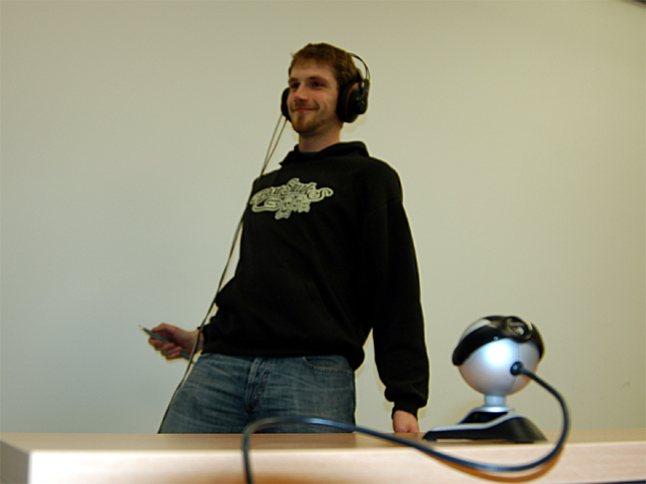

Figure 2: Playing MatrixShot

As we can not compete with professional game developers, we have just prototyped some game ideas for audio based gaming. We designed three simple action games and one narrative adventure, of which all share the same framework and similar techniques for sonification and interaction.
One of the games is an acoustic remake of the classic Frogger game [16], in which the player has to cross a street and listen carefully to avoid getting hit by the traffic. This game is a straightforward implementation and uses 3D sounds, head-tracking and a joystick/keyboard for player movement. The second game was called Mosquitos and is played with an additional 3D pointing device, which is used as an insect spray to defend oneself against attacking mosquitos, flies and bees. The game is played in full 3D, 360° around the user. The third game integrates the EyeToy feature [17] into our framework and audio gaming, see also Figure 2. The player is positioned in front of a standard webcam and tries to avoid getting shot by virtual bullets. The game was called MatrixShot, as the evasive maneuvers tend to be very artistic. All of the games can vary in difficulty through the amount of objects that need to be tracked, as well as trough game music, which can distract and complicate the sound source locating. The challenge in all games is to listen carefully to determine the sounds position and to react appropriately.
Although our adventure “The hidden Secret” shares the same framework, yet it is a completely different game and puts the player in the role of a tourist who explores the ancient cathedral in our city. Several myth and legends have been combined into a single story, and the player is about to unfold a mystery about a long lost treasure. Monologues and communications with other characters control the story as the player explores the environment. The next evolution of the game would be to turn it into an augmented audio application, and to play the game in its real environment.

4. SUMMARY AND FUTURE WORK
In this paper we tried to motivate for the advantages of audio based computer games and provided several examples to support this. We sketched the possibilities of the available game genres and described in detail the necessary techniques to design and develop audio games. In addition, we presented our framework, which implements many of the discussed sonification and interaction techniques and can be used to efficiently design virtual, auditory worlds. This was demonstrated by a discussion of four prototypic implementations of audio-only computer games.
The possibilities for future improvements are manifold and include an extension of the existing system by additional sonification and interaction techniques, as well as by integrating a more advanced sound rendering system. Additionally, we would like to extend the system and develop a truly mobile solution that allows the exploration of the possibilities for augmented, audio applications. Furthermore, we would like to evaluate the potential of consumer tracking devices to develop a more affordable consumer system.

5. REFERENCES
[1] Gavin Andresen. Playing by Ear: Creating blind-accessible Games. In Gamasutra Article, May 2002.
[2] Durand R. Begault. 3D Sound - For Virtual Reality and Multimedia. AP Professional, 1994.
[3] Wikipedia Community. Wikipedia Online Encyclopedia. http://www.wikipedia.org/, 2005.
[4] Cyberworld. Cyberworld online shop. Website, 2005. http://www.cwonline.com/.
[5] Fachhochschule Stuttgart. Tanja Dannecker, Matthias Pasedag, Christa Stoll, and Heinrich Sturm. Der Tag wird zur Nacht, 2003. PC.
[6] Danz Games. Super Deekout. http://www.danzgames.com/superdeekout.htm, 2004. PC.
[7] Thomas M. Drewes, Elizabeth D. Mynatt, and Maribeth Gandy. Sleuth: An audio experience. In ICAD2002, 2002.
[8] Johnny Friberg and Dan Gärdenfors. Audio games: New perspectives on game audio. In Advances in Computer Entertainmet Technology ’04, Singapore, 2004.
[9] John Garas. Adaptive 3D Sound Systems. Kluwer Academics, 2000.
[10] Pin Interactive. Terraformers, 2003. PC.
[11] Christopher Lewis. Audio Formula 1, 2003. PC.
[12] Kent Lyons, Maribeth Gandy, and Thad Starner. Guided by voices: An audio augmeted reality system. In ICAD2000, 2000.
[13] Niklas Röber and Maic Masuch. Auditory Game Authoring: From virtual Worlds to auditory Environments. In CGAIDE 2004, pages 114–121, 2004.
[14] Niklas Röber and Maic Masuch. Interacting with Sound: An interaction Paradigm for virtual auditory Worlds. In ICAD 2004, 2004.
[15] http://www.audiogames.net, 2005.
[16] Sierra Inc. On-Line. Frogger, 1983. PC.
[17] Sony. EyeToy: Play, 2003.
[18] S. D. Speeth. Seismometer Sounds. In Journal of the Acoustical Society of America, volume 33, pages 909–916, 1961.
[19] Sue Targett and Mikael Fernström. Audio games: Fun for all? All for fun? In ICAD2003, 2003.
[20] USA Games. Star Trek - Final Conflict. http://www.usagames.us, 2005. PC.
[21] Yishay Cohen and Jolanda Dekker and Arnout Hulskamp and David Kousemaker and Tim Olden and Cees Taal and Wouter Verspaget. Demor - Location based 3D Audiogame. http://student-kmt.hku.nl/_g7/site/, 2004.
PLAYING AUDIO-ONLY GAMES
A COMPENDIUM OF INTERACTING WITH VIRTUAL, AUDITORY WORLDS

Niklas Röber and Maic Masuch
Games Research Group
Department of Simulation and Graphics
University of Magdeburg, Germany
nroeber|masuch@isg.cs.uni-magdeburg.de

ABSTRACT
Talking about games refers in today’s world often to the play of audio-visual computer games. Since their first introduction in the 1960s, computer games have evolved in many ways and are today one of the fastest growing industries. Besides the classic visual games, another niche has emerged over the last decade: audio-only computer games. The main difference to conventional games is that these games can only be played and perceived through sound and acoustics. Although, initially developed by and for the visually impaired community, these games posses huge potentials for mobile (transportable) gaming and can be enjoyed by all hearing.
In this work we present an overview of audio-only games, and discuss the methods and techniques to play and design such auditory worlds. We further explore the evolved genres and address the advantages, as well as the limitations of audio based gaming. Our work is motivated by our own research in this area and the development of a framework, which allows an easy design and setup of audio-only computer games.

Keywords
Audio-only computer games, 3D sound, auditory environments, sonification, interaction.

BIOGRAPHY

Niklas Röber received his Diplom (Master’s degree) from the Otto-von-Guericke University of Magdeburg in 2002. He is currently working on his PhD, focusing on sonification and interaction techniques for virtual, auditory worlds. His current research interests include auditory interfaces, acoustic rendering as well as non-photorealistic rendering techniques. Previous work contains research in computer graphics and scientific visualization. He is a member of the IGDA Society.

Maic Masuch PhD in computer animation, graduated at University of Magdeburg, Germany where he is now Germany's first professor for computer games. He has been teaching and researching on computer game programming for six years.
Research focuses on authoring of virtual worlds, user interfaces, audio-only-interfaces and graphics for games, especially real-time non-photorealistic rendering techniques for game engines. He supervised several game-related student projects and works as a game consultant for game development companies and the German ministry of research. In addition, Prof. Masuch is co-founder of Impara, a technology think tank that is developing media systems for playful learning.

